Nmap Scripting Engine:

ls -la /usr/share/nmap/scripts/

default scripts:
nmap -sS -p- -T4 -sV -O -sC 192.98.124.3

NOTE:
we can extract a lot from the services ,if they are mis comfigured then it reveal a info about an target os.

To get info about script:

Nmap - -script-help=(name of script)

To run a particular script:

nmap -sS -p- -T4 -sV -O - -script=mongodb-info 192.98.124.3

Memcached script searching:
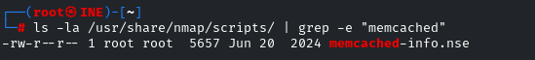

nmap -sS -p- -T4 -sV -O --script=memcached-info 192.98.124.3

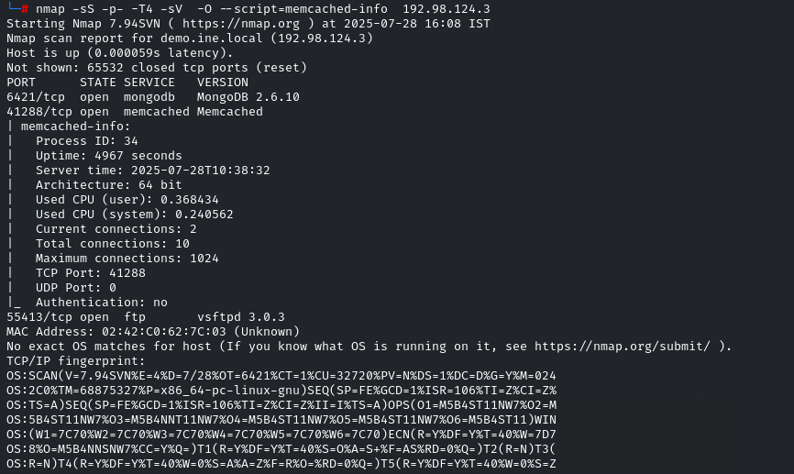

nmap --script-help=memcached-info
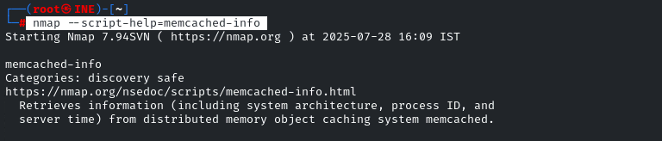

ftp:
ls -la /usr/share/nmap/scripts/ | grep -e "ftp"
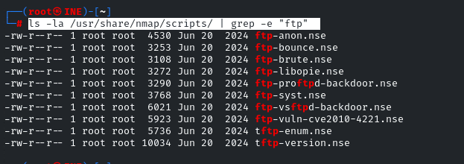

nmap --script-help=ftp-anon
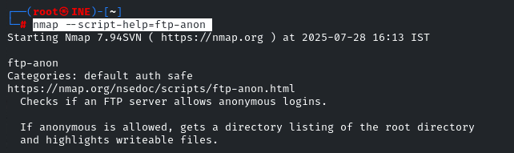

nmap -sS -p- -T4 -sV -O --script=ftp-anon 192.98.124.3

all ftp scripts:
nmap -sS -p- -T4 -sV -O --script=ftp-* 192.98.124.3

